Gold Tip Velocity Valkyrie With First Ever Factory Four Fletch Arrow!
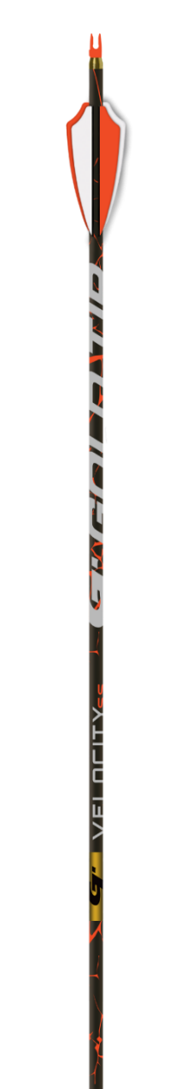
Experienced shooters know that four vanes give you increased drag, faster stabilization, and tighter groupings. With the launch of the new Velocity Valkyrie, Gold Tip introduces four fletching straight from the factory - for the first time ever! The Valkyrie comes Factory Four Fletched with aggressive graphics, lightweight construction and four low-profile vanes for added surface area without sacrificing clearance or speed. That means more back-end drag, faster stabilization, and group size reductions of 20-75% with broadheads! Add to that Gold Tip’s 100% Pure Carbon technology for unmatched straightness retention and toughness and you get the Valkyrie. It’s screaming speed with Factory Four Fletch accuracy.

FEATURES
- Aggressive Graphics
- .003” Straightness
- Light-weight Velocity Construction
- +/- .5 grain Weight Tolerances
- 5 Spine Offering: 300, 340, 400, 500, 600
- Also now available in Hunter Pro, Velocity Pro, Kinetic Kaos, and Kinetic Pierce Platinum

Part No. Description UPC MSRP
Velocity Valkyrie $129.99

