Pro 60X
Cook like a pro wherever you go with the Pro 60X two-burner stove. With two 30,000 BTU burners, matchless ignition, and a three-sided windscreen, cooking outdoors has never been easier. You can create culinary masterpieces wherever you go with all the mix-and-match 14-inch accessories. Munch on pizzas at the campsite, grill steaks in the backyard, fry bacon at the tailgate party, and more. Two folding side shelves give you the extra room you need for utensils and prep work, while built-in leg levelers make it easy to stand your stove on uneven ground. With so many incredible features packed into one stove, you’ll love what you get from the Pro 60X. Add it to your outdoor kitchen today.

Features & Benefits
  - Two cast-aluminum 30,000 BTU burners
  - Adjustable heat-control dials for precise cooking
  - Matchless ignition
  - Three-sided windscreen
  - Folding side shelves
  - Deluxe folding legs
  - Adjustable leg levelers for uneven ground
  - Steel handle on back of stove for easy transport
  - 448 sq. in. cooking surface area

Part No. Description UPC MSRP
Pro60X Professional two-burner stove 0-33246-21389-7 $229.99

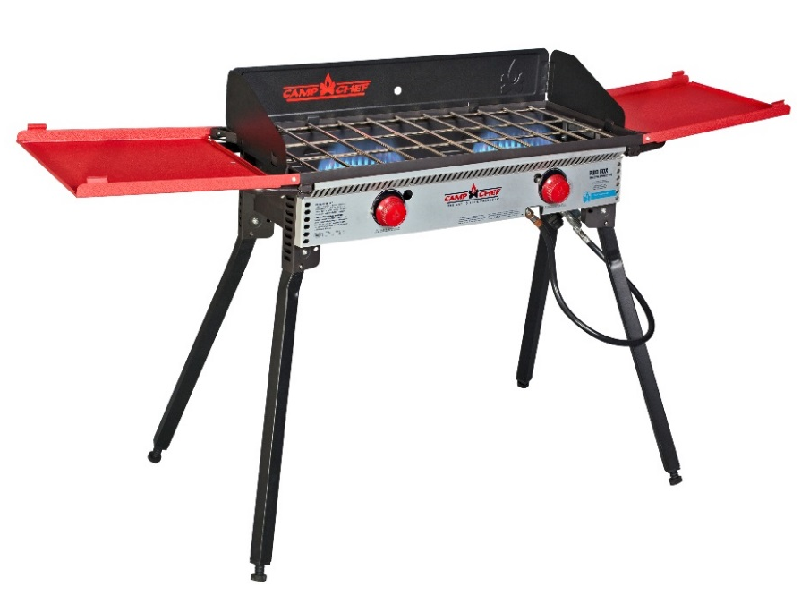

Pro 90X
Cooking for a group is simple with the Pro 90X. Three powerful 30,000 BTU burners give you the cooking power and surface area to whip up food for even the biggest cookouts. You can use multiple 16-inch accessories at once: a pizza oven on one side with a griddle on the other, a Dutch oven on the right and a BBQ box on the left—the possibilities are endless. A three-sided windscreen, adjustable leg levelers, and matchless ignition make it easy to cook on the Pro 90X wherever you are, whether that’s the campsite or the tailgate party. Folding side shelves and legs make for easy portability when it’s time to pack up. You’ll wonder how you ever cooked on any other stove. Get yourself the Pro 90X today.

Features & Benefits

  - Three cast-aluminum 30,000 BTU burners
  - Adjustable heat-control dials for precise cooking
  - Matchless ignition
  - Three-sided windscreen
  - Folding side shelves
  - Deluxe folding legs
  - Large cooking area allows you to cook for groups
  - Adjustable leg levelers for uneven ground
  - Steel handle on back of stove for easy transport
  - 608 sq. in. cooking surface area

Part No. Description UPC MSRP
PRO90X Professional three-burner stove 0-33246-21390-3 $279.99

