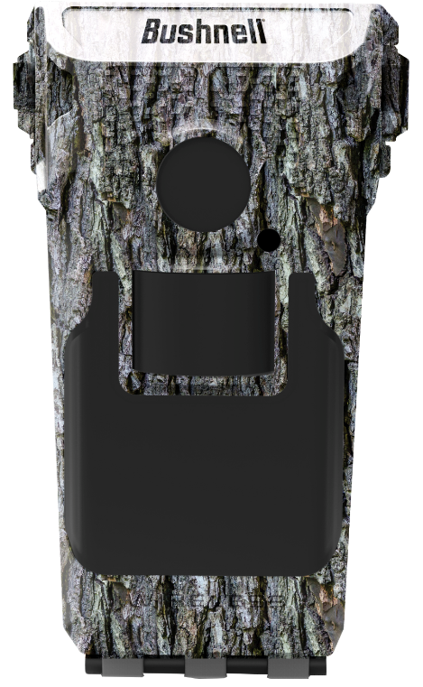
(IMAGE NOT FINAL)

The Impulse Cellular Trail Camera is the result of innovative and relentless engineering that delivers Cellular. Faster. Better. Impulse makes it faster than ever to get connected with easy setup to any smartphone and any provider, with no contract. Ultra-fast dual processors work simultaneously to take 1 picture per second versus 1 per minute with competitor cameras. That means you get more images of each animal passing by. And it’s loaded with smarter features that help you make better use of your time and money—like sorting photos by weather and wind data, GPS anti-theft alerts, and live camera views from your phone.
Camera Specifications:
- 20MP HD Images
- 1080p HD Video
- 6 Month Battery Life
- 0.2 Second Trigger Speed
- 5 second image recovery
- 100’ No Glow Flash
Impulse™ Cellular Trail Camera

Camera Features:
- AT&T and Verizon Options
- 1 Second Image Recovery
- Cellular Video Transmission
- Active GPS
- 150’ Wi-Fi/Bluetooth Connectivity
- Camera Leveling Arm
- Live Capture
- Live View
- Weather Data Image Tags
- Solar Panel Compatible
- Anti-Theft Mode
Benefit:
Better cellular coverage
More pictures than any other cellular camera
Retrieve video without going to the camera
Allows user to navigate to the camera if it is moved
Instant high res downloads and setting changes
Perfect lens alignment in any condition
User commands camera to take a picture at any time
User sees exactly what the camera sees during set up
Complete weather info at the time of image capture
Solar Panel provides near infinite battery life
Alerts owner if camera is moved, deactivates everything
but the GPS

SKU | NAME | UPC | MSRP
119900A | Impulse Cellular Trail Camera AT&T | 0-29757-00331-7 | $299
119900V | Impulse Cellular Camera Verizon | 0-29757-00407-9 | $299

