Elite® Tactical 1-6x 24mm SMRS with Ultra Bright Dual-Plane Reticle
Bushnell’s new Elite Tactical 1-6x 24mm SMRS (Short Mid-Range Scope) leads the way in tactical design with the new Ultra Bright tactical dual-focal plane reticle. This reticle integrates the close-range, quick targeting of a second focal plane illuminated dot that does not change size with magnification adjustment, and the medium- to long-range versatility of a first focal plane ranging reticle. The SMRS with Dual-Plane bridges the gap between red dots and tactical scopes to provide the ultimate in versatility for shooters who demand a close/mid-range illuminated riflescope. It provides unprecedented reticle brightness that can be seen even on sunny days and is versatile enough to be used for CQB or engaging targets out to 600 yards. The scope has a rugged 30mm, one-piece tube and the ThrowDown Power Change Lever for ultra-fast adjustment.

Features & Benefits
- Ultra bright red dot performance at low magnification and ranging reticle capability at high magnification
- Unique design places the reticle in both the first and second focal plane
- True 1x for ultimate field of view at low power
- ThrowDown PCL (Power Change Lever) for ultra-fast power adjustments
- 30mm tube for increased adjustment travel
- T-Lok locking target turrets
- RainGuard® HD lens coatings
- Fully multi-coated optics with exclusive Ultra Wide Band lens coatings
- Fast-focus eyepiece for reticle clarity

Part No. Description UPC MSRP
ET1625DP Elite Tactical 1-6.5x 24mm Ultra Bright dual-plane reticle 0-29757-16255-2 $2,100.45

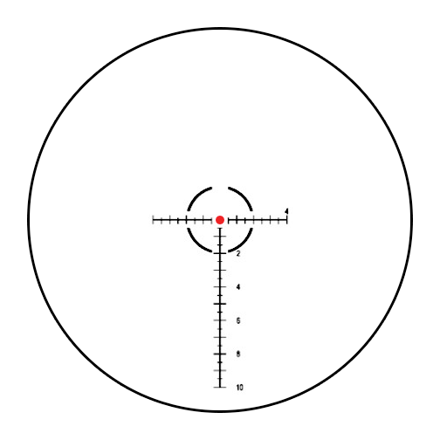
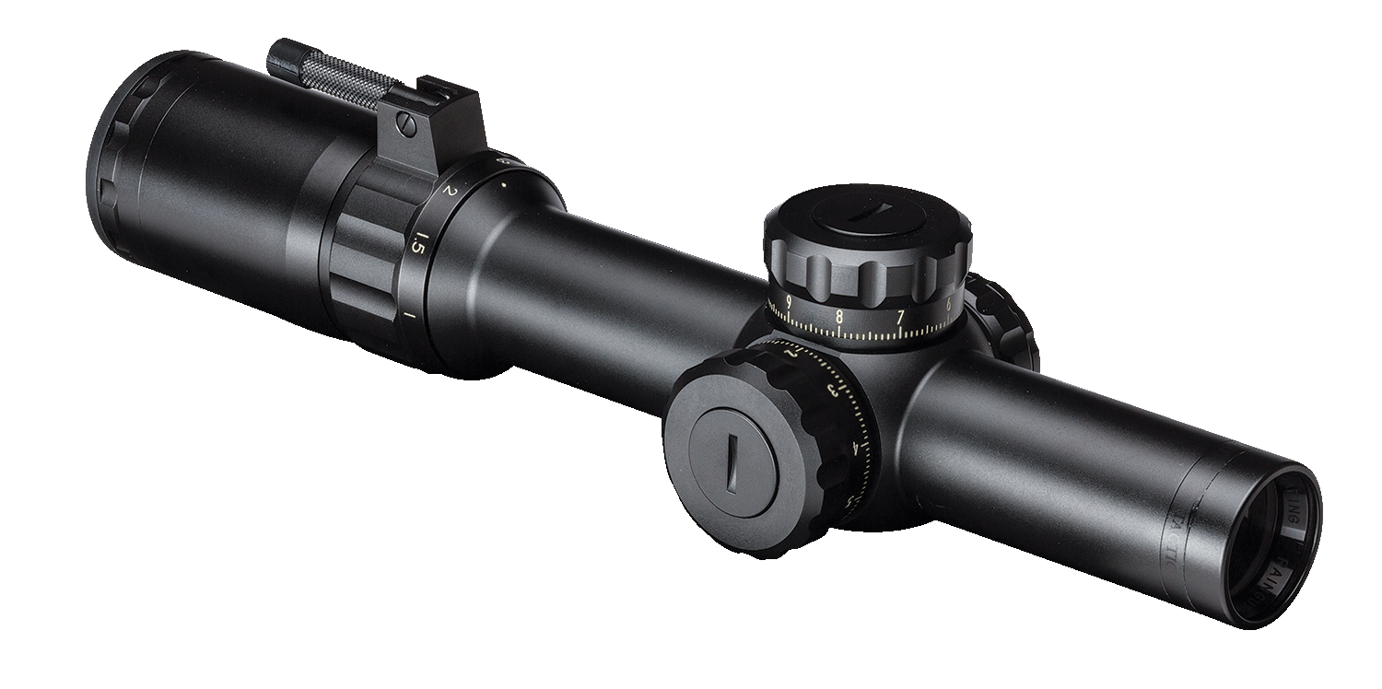
Ultra Bright Dual-Plane Tactical Reticle

