Elite® 6500
For 2015, the Elite line of riflescopes has been reengineered to offer three levels of high-end precision—the Elite 3500, 4500 and 6500. The 6500 series is the pinnacle of performance, packing 65-plus years of innovation into an ultra-rugged scope that delivers a powerful 6.5x magnification range and a 30mm one-piece tube for extra adjustment travel and unfailing reliability that is magnum recoil-proof. Fully multi-coated optics combined with Bushnell's exclusive Ultra Wide Band Coating process boost light transmission through the scope to 95 percent, offering incredible brightness during those the first and last minutes of shooting light. The patented RainGuard® HD coating offers a permanent barrier that beads water to scatter less light and give a clear view in conditions that would render untreated optics unusable. And, of course, they are backed by Bushnell’s 100% Bulletproof Money-Back Guarantee.

Features & Benefits
- Powerful 6.5x zoom ratio
- Rugged aluminum/titanium alloy, one-piece, 30mm tube
- RainGuard HD lens coatings
- Side parallax adjustment for pinpoint shot placement at any distance
- Fully multi-coated optics
- Ultra Wide Band lens coatings
- Magnum recoil-proof construction
- Argon purged for 100 percent waterproof and fogproof construction
- Finger-adjustable elevation and windage knobs

Part No. Description UPC MSRP
652164B Elite 6500 2.5-16x 42mm DOA 600 0 29757 61214 4 $1,123.95
652164M Elite 6500 2.5-16x 42mm Fine Multi-X 0 29757 65216 4 $1,053.45
652164MD Elite 6500 2.5-16x 42mm Mildot 0 29757 65217 1 $1,053.45
652165M Elite 6500 2.5-16x 50mm Fine Multi-X 0 29757 65215 7 $1,093.45
652165MD Elite 6500 2.5-16x 50mm Mildot 0 29757 65218 8 $1,093.45
654305B Elite 6500 4.5-30x 50mm DOA 600 0 29757 65433 5 $1,334.45
654305M Elite 6500 4.5-30x 50mm Fine Multi-X 0 29757 65430 4 $1,264.45
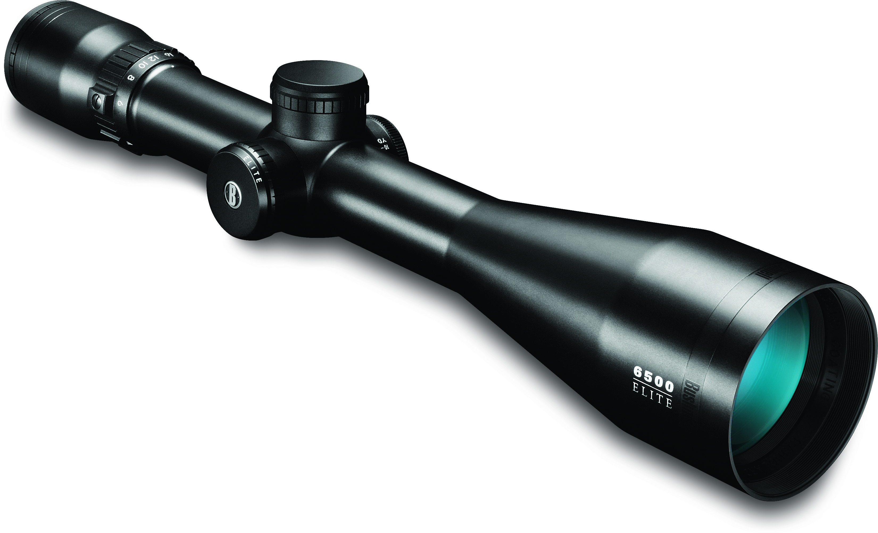
654305MD Elite 6500 4.5-30x 50mm Mildot 0 29757 65431 1 $1,264.45

