Competition Reflex Holster
Its father has been on duty for 15 years. Its mother was the first injection molded concealment holster on the market. The new Competition Reflex Holster is another evolution, precision engineered by the Uncle Mike's® Team to meet the rigorous demands of competition shooting. This molded competition model blends the street-proven, ultra-reliable I.R.T. (Integrated Retention Technology) with a removable holster system. Now competition shooters can safely store their firearms between stages and then reattach them in the same belt position every time. Designed to meet the challenge of performing on the biggest stage with gross motor skill function in almost any condition, the new Competition Reflex allows professionals to enter each course of fire with confidence that their firearm is secure and can be drawn as fast as a Reflex.

Features & Benefits
- Integrated Retention Technology uses a fast, simple grip and twist action to release firearm for draw
- Removable holster system allows quick detach and positive reattachment
- Injection molded impact-modified polymer construction
- Made in the USA

Part No. Description UPC MSRP
74217 Competition Reflex, RH Glock 0 43699 74217 2 $59.95
74219 Competition Reflex, LH Glock 0 43699 74219 6 $59.95
74097 Competition Reflex, RH M&P 0 43699 74097 0 $59.95
74099 Competition Reflex, LH M&P 0 43699 74099 4 $59.95
74117 Competition Reflex, RH 1911 0 43699 74117 5 $59.95
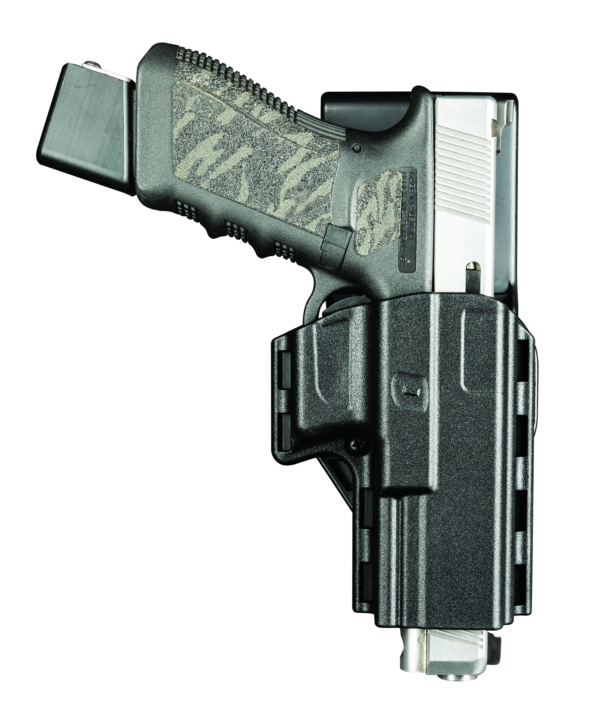
74277 Competition Reflex, RH XD 0 43699 74277 6 $59.95

