2015 new Products

Presses

Pro Chucker 5 Progressive Press
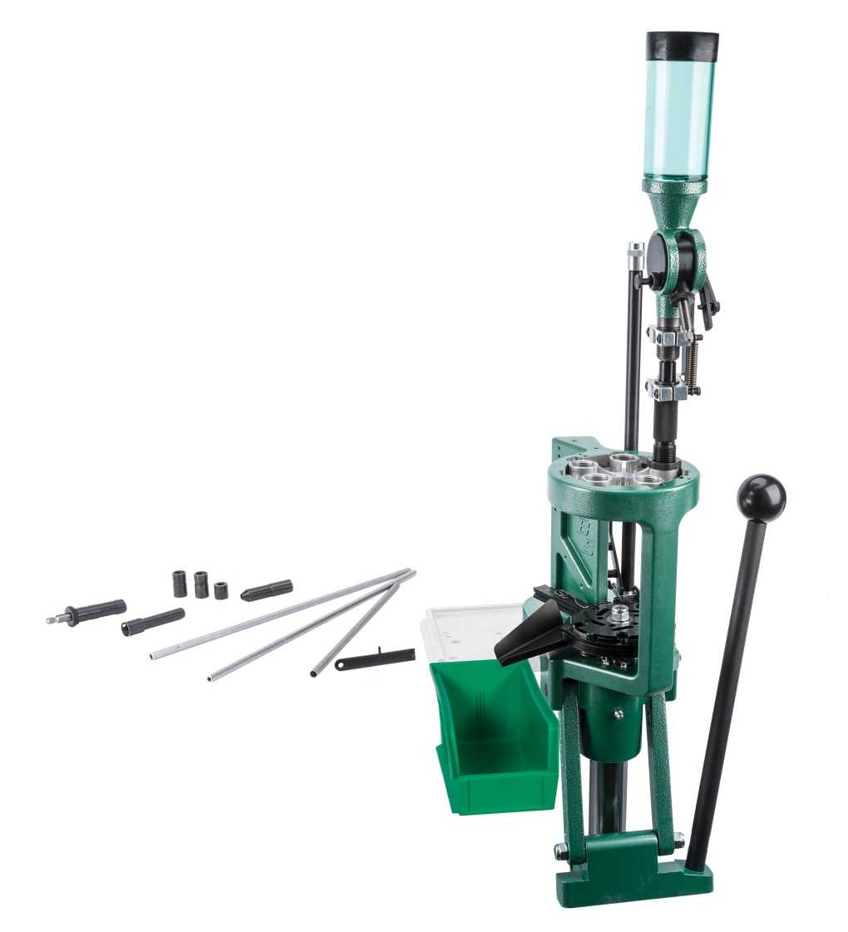
The new RCBS® Pro Chucker 5 Auto Index Progressive Press is the next level in reloading efficiency and customization. It features five-station automatic indexing for maximum production, with a load rate of approximately 600 rounds per hour. The quick-change die plate allows fast caliber change over for even greater efficiency. Standard primer pick up tubes are used with the safety-shielded priming system. Spent primers are efficiently dropped from the bottom of the press to be captured in a trash receptacle. The powder measure is fitted with Quick Change metering components that allow you to drain powder without removing the measure from the press. You can also quickly swap out preset metering screws for dispensing the new powder. Plus, the new Pro Chucker 5 is the first progressive press that can be converted from five- to seven-station operation.

Features & Benefits
- Five-station auto indexing
- 4.625” operating window
- Quick-change die plate
- Quick Change powder measure metering components
- Die cast aluminum frame
- Zerk fitting for lubrication
- Loaded cartridge bin
- Load rate ~600 rounds per hour (pistol)
- Limited lifetime warranty
- Made in U.S.A.

Part No. Description UPC MSRP
88910 Pro Chucker 5 Progressive Press 0 76683 88910 2 $778.95

2015 new Products

Presses

Pro Chucker 7 Progressive Press
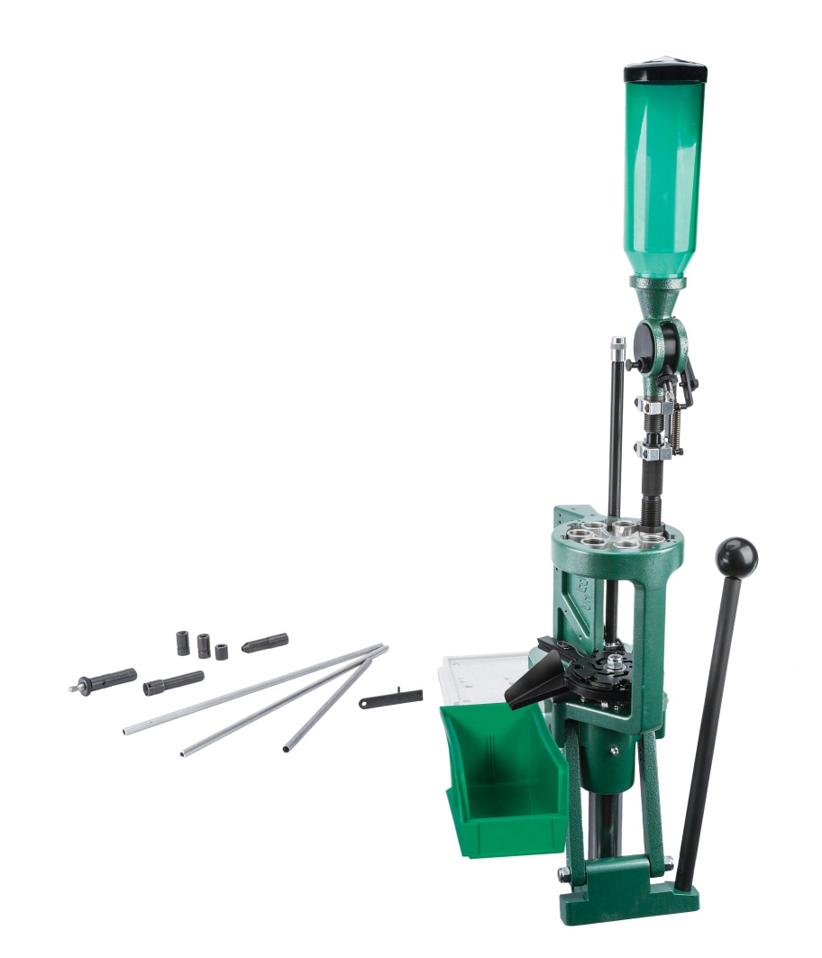
Take reloading to the elite level with new RCBS® Pro Chucker 7 Auto Index Progressive Press. The first seven-station auto-indexing press on the market, The Pro Chucker 7 features automatic indexing for maximum production, with a load rate of approximately 600 rounds per hour. The quick-change die plate allows fast caliber change over for even greater efficiency. Standard primer pick up tubes are used with the safety-shielded priming system. Spent primers are efficiently dropped from the bottom of the press to be captured in a trash receptacle. The large powder capacity Quick Change powder measure reduces the number of times you have to fill the powder hopper. Plus, the Quick Change drain tube allows you to drain the powder measure without removing it from the press. QC metering assemblies allow shortened set up times when switching powders. Seven stations allows you to progressive load any way you want: Seat bullets and crimp separately. Use a bullet feeder but also use a Lock-Out or Powder Checker die. With seven stations, you can do it all.

Features & Benefits
- Seven-station auto indexing
- 4.625” operating window
- Quick-change die plate
- Quick Change powder measure
- Die cast aluminum frame
- Zerk fitting for lubrication
- Loaded cartridge bin
- Load rate ~600 rounds per hour (pistol)
- Limited lifetime warranty
- Made in U.S.A.

Part No. Description UPC MSRP
88911 Pro Chucker 7 Progressive Press 0 76683 88911 9 $1098.95

2015 new Products

Presses

Pro Chucker 5 to 7 Conversion Kit
When you are ready to upgrade your Pro Chucker 5 to seven-station operation, the Pro Chucker 5 to 7 Conversion Kit has everything you need. It includes a seven-station die plate, shell plate holder assembly, large and small priming system, Quick Change powder measure and case activated linkage kit.

Features & Benefits
- Converts Pro Chucker 5 to Pro Chucker 7
- Includes:
- Seven-station die plate
- Shell plate holder assembly
- Large and small priming system
- Shell Plate Indexing system
- Quick Change powder measure
- Limited lifetime warranty
- Made in U.S.A.

Part No. Description UPC MSRP
88914 Pro Chucker 5 to 7 Conversion Kit 0 76683 88914 0 $383.95

2015 new Products

Accessories

Pro Chucker Accessories
Use these high-quality, precision-manufactured accessories to configure the Pro Chucker 5 and Pro Chucker 7 Auto Index Progressive presses.

Features & Benefits
- Limited lifetime warranty
- Made in U.S.A.

Part No. Description UPC MSRP
88912 Pro Chucker 5 die plate 0 76683 88912 6 $31.95
88913 Pro Chucker 7 die plate & powder measure 0 76683 88913 3 $319.95
88920 Pro Chucker 5 station shell plate #2 0 76683 88920 1 $47.95
88921 Pro Chucker 5 station shell plate #3 0 76683 88921 8 $47.95
88922 Pro Chucker 5 station shell plate #4 0 76683 88922 5 $47.95
88923 Pro Chucker 5 station shell plate #6 0 76683 88923 2 $47.95
88924 Pro Chucker 5 station shell plate #10 0 76683 88924 9 $47.95
88925 Pro Chucker 5 station shell plate #11 0 76683 88925 6 $47.95
88926 Pro Chucker 5 station shell plate #12 0 76683 88926 3 $47.95
88927 Pro Chucker 5 station shell plate #13 0 76683 88927 0 $47.95
88928 Pro Chucker 5 station shell plate #14 0 76683 88928 7 $47.95
88929 Pro Chucker 5 station shell plate #16 0 76683 88929 4 $47.95
88930 Pro Chucker 5 station shell plate #17 0 76683 88930 0 $47.95
88931 Pro Chucker 5 station shell plate #18 0 76683 88931 7 $47.95
88932 Pro Chucker 5 station shell plate #19 0 76683 88932 4 $47.95
88933 Pro Chucker 5 station shell plate #20 0 76683 88933 1 $47.95
88934 Pro Chucker 5 station shell plate #23 0 76683 88934 8 $47.95
88935 Pro Chucker 5 station shell plate #27 0 76683 88935 5 $47.95
88936 Pro Chucker 5 station shell plate #30 0 76683 88936 2 $47.95
88937 Pro Chucker 5 station shell plate #32 0 76683 88937 9 $47.95
88938 Pro Chucker 5 station shell plate #35 0 76683 88938 6 $47.95
88939 Pro Chucker 5 station shell plate #38 0 76683 88939 3 $47.95
88940 Pro Chucker 5 station shell plate #39 0 76683 88940 9 $47.95
88941 Pro Chucker 5 station shell plate #43 0 76683 88941 6 $47.95
88942 Pro Chucker 5 station shell plate #44 0 76683 88942 3 $47.95
88943 Pro Chucker 5 station shell plate #45 0 76683 88943 0 $47.95
88944 Pro Chucker 5 station shell plate #48 0 76683 88944 7 $47.95
88950 Pro Chucker 7 station shell plate #2 0 76683 88950 8 $67.45
88951 Pro Chucker 7 station shell plate #3 0 76683 88951 5 $67.45
88952 Pro Chucker 7 station shell plate #4 0 76683 88952 2 $67.45
88953 Pro Chucker 7 station shell plate #6 0 76683 88953 9 $67.45
88954 Pro Chucker 7 station shell plate #10 0 76683 88954 6 $67.45
88955 Pro Chucker 7 station shell plate #11 0 76683 88955 3 $67.45
88956 Pro Chucker 7 station shell plate #12 0 76683 88956 0 $67.45
88957 Pro Chucker 7 station shell plate #13 0 76683 88957 7 $67.45
88958 Pro Chucker 7 station shell plate #14 0 76683 88958 4 $67.45
88959 Pro Chucker 7 station shell plate #16 0 76683 88959 1 $67.45

88960 Pro Chucker 7 station shell plate #17 0 76683 88960 7 $67.45
88961 Pro Chucker 7 station shell plate #18 0 76683 88961 4 $67.45
88962 Pro Chucker 7 station shell plate #19 0 76683 88962 1 $67.45
88963 Pro Chucker 7 station shell plate #20 0 76683 88963 8 $67.45
88964 Pro Chucker 7 station shell plate #23 0 76683 88964 5 $67.45
88965 Pro Chucker 7 station shell plate #27 0 76683 88965 2 $67.45
88966 Pro Chucker 7 station shell plate #30 0 76683 88966 9 $67.45
88967 Pro Chucker 7 station shell plate #32 0 76683 88967 6 $67.45
88968 Pro Chucker 7 station shell plate #35 0 76683 88968 3 $67.45
88969 Pro Chucker 7 station shell plate #38 0 76683 88969 0 $67.45
88970 Pro Chucker 7 station shell plate #39 0 76683 88970 6 $67.45
88971 Pro Chucker 7 station shell plate #43 0 76683 88971 3 $67.45
88972 Pro Chucker 7 station shell plate #44 0 76683 88972 0 $67.45
88973 Pro Chucker 7 station shell plate #45 0 76683 88973 7 $67.45
88974 Pro Chucker 7 station shell plate #48 0 76683 88974 4 $67.45

