Federal Leads the Charge in Creating a New, Ground-Breaking Muzzleloader Rifle System

Answers to frequently asked questions about Federal’s New FireStick: A new system that will change the world of muzzleloader hunting forever.

Hunting white-tailed deer during muzzleloader-only season is typically a way to spend more time in the field for a rifle or shotgun hunter. However, antique firearms and even modern inline muzzleloaders do have their frustrations and limitations. So much so, that the hassle of operating them can be a deterrent for some hunters and can be considered a barrier to enter the sport.
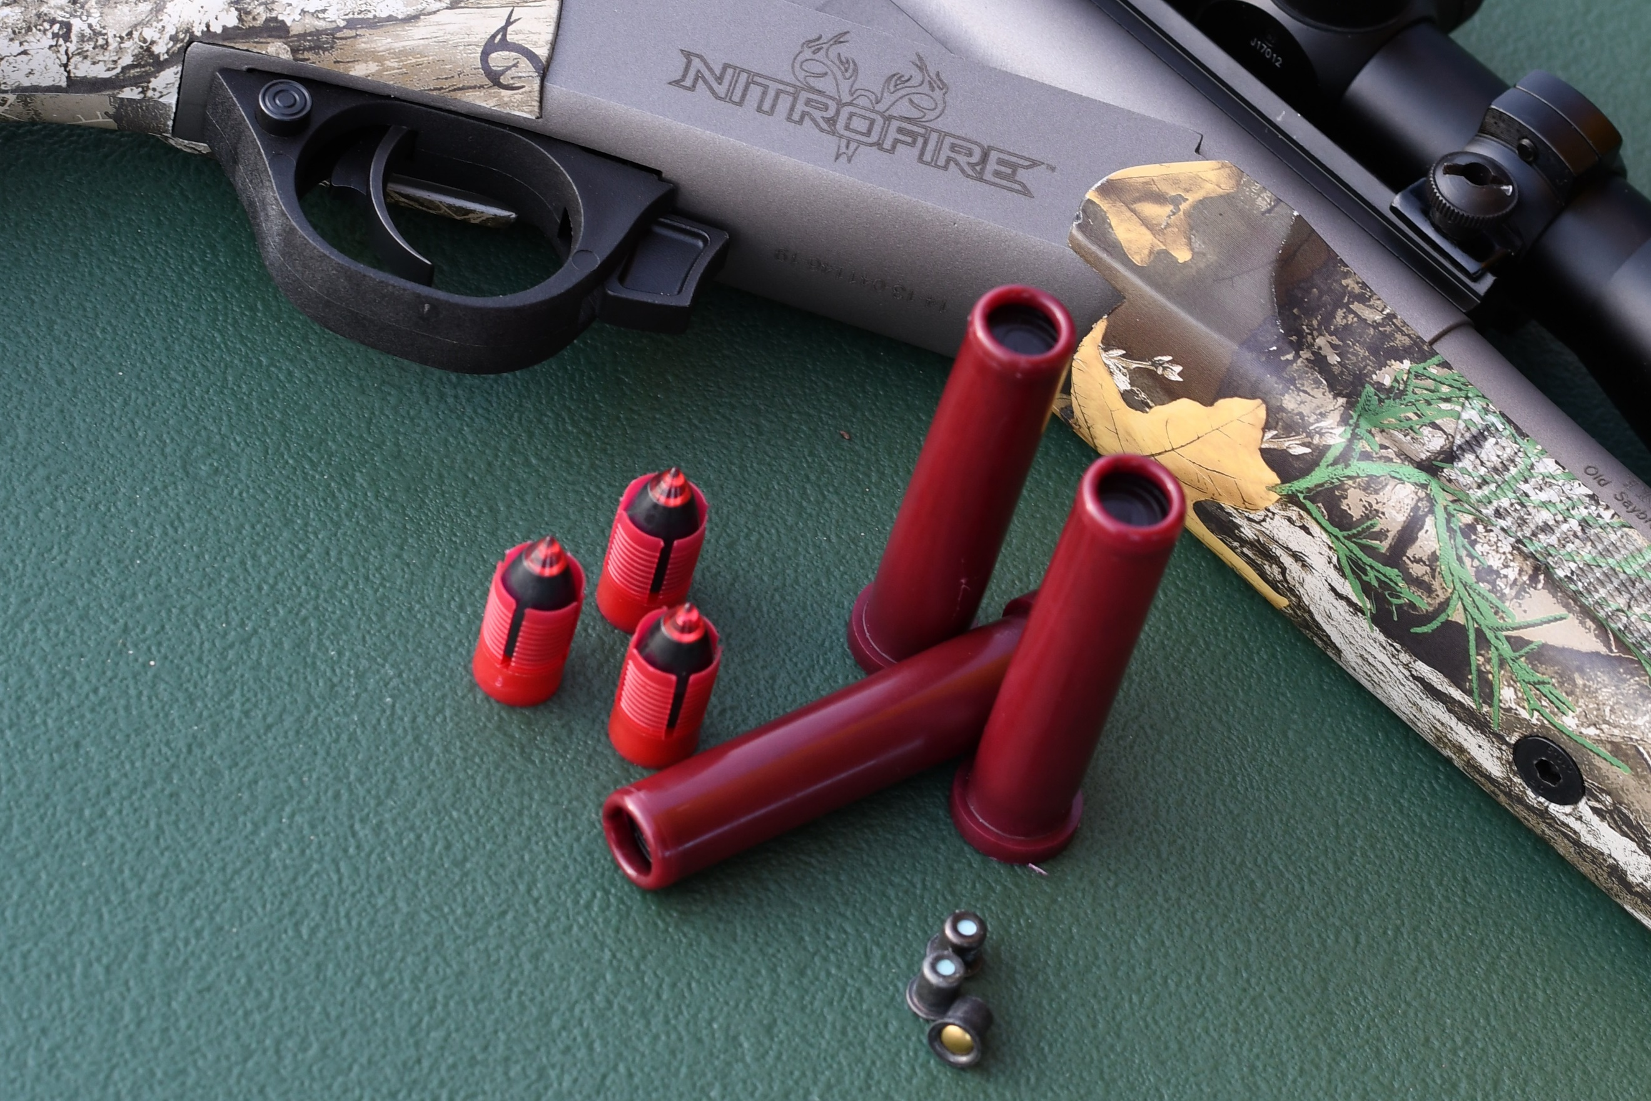
The expert engineers at Federal Ammunition knew there could be a better, easier and safer way. New for 2020, Federal Ammunition is launching a proprietary and newly-patented muzzleloading propellant system that is safer and easier to use than ever before. This revolutionary invention was completed by Federal in conjunction with Traditions Firearms to rejuvenate muzzleloader hunting. Enter Federal’s ground-breaking, new FireStick propellant capsule powered by Hodgdon’s new Triple 8 granular powder.
This article explains the product in detail, and answers many of the frequently asked questions about it. Quotes can be attributed to Federal Ammunition Muzzleloader Product Manager Dan Compton.

What inconsistencies or issues plague today’s muzzleloader hunters and shooters?
As long as there have been muzzleloading firearms, their shooters have been burdened by unreliability, inconsistency and safety concerns. That said the list of muzzleloader complaints include:

- Environmental conditions can lead to powder charges exposed to moisture. Moisture leads to misfires. A muzzleloader shooter must always be aware of exposure to moisture such as rain, snow or moisture sweating—coming in and out of the cold—when operating a muzzleloader.
- Dirty powders residue and powder fouling reduce the ability to load and shoot quickly, accurately and repeatedly without cleaning between shots.
- Spent powder residue attracts moisture and leads to corrosion which can lead to damage done to the inside of the breech area and barrel. This makes rifles hard to clean, as well as requiring a lot of cleaning between uses.
- Dirty primer pockets and hard to clean breech plugs could lead to misfires. The hassle of inserting or losing primers, plus keeping them protected from the elements are always concerns.
- Loose powder charges measured by volume are not very precise and could lead to inconsistencies in accuracy. For example not pouring the exact amount—too much, or too little—powder every time you load the rifle.
- Due to human error, there is always a risk of crushing propellant pellets when loading bullets on top of them—meaning pushing the bullet down too much. Or not pushing down the bullet enough, leaving an air gap between the powder charge and the bullet. These common loading and charging errors cause inconsistencies in accuracy.
- Due to human error, there is always a risk of over-filling a powder charge to dangerous levels or using incorrect powder such as smokeless powder in a muzzleloader firearm designed for traditional black powder or black powder substitute.
- Once opened, traditional loose powder or propellant powders can be exposed to moisture and other damaging elements or become old, leading to inconsistent powder charges resulting in accuracy issues.
- To unload, it’s typical to fire the rifle or safely take out the breech plug to remove the powder charge. This can be a loud annoyance or hassle and wastes money in spent bullets and powder that need to be replaced.
- The use of muzzleloaders is not as common as centerfire rifles. The process of loading, unloading and cleaning has been known to prevent people from trying it out. This new system makes selecting the powder aspect much easier. The loading and unloading process has now been streamlined and much of the mystery of “How do I do this?” is taken out of the equation.
What exactly is a FireStick?
Federal Premium FireStick is a part of a whole new muzzleloader system that uses a primer inserted into an encapsulated powder charge. In other words, it’s a premeasured self-contained powder charge.
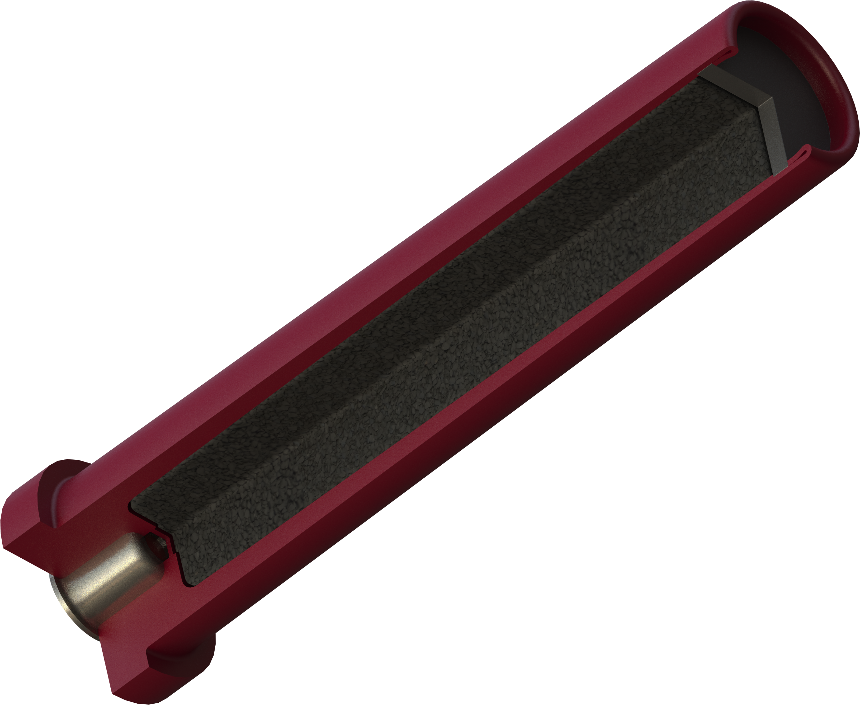
First, the bullet is loaded separately and independently from the muzzle to seat on top of a bullet shelf inside the barrel of the rifle. The break-open action of the rifle is opened. The FireStick is installed into the open breech to seat just behind the bullet shelf and seated bullet. A 209 Muzzleloader primer is inserted into the FireStick propellant capsule to charge the powder. The break-open action is closed. It’s now ready to fire, once the hammer is pulled back and the safety is turned off.
Physical features of the FireStick consist of a polymer capsule precisely filled with an exact charge of all-new, ultra-clean black powder substitute Hodgdon Triple 8 granular powder. The sealed capsule utilizes a breakable front section (cap) that completely encases the powder charge.
The FireStick propellant capsule requires a 209 primer (sold separate) to be inserted into it by the user to become charged. The user inserts a 209 Shotshell Primer, of their choice, to fully charge the system.
Once inserted, the primer doesn’t need to be uninstalled. The primer can remain inserted into the FireStick. Keeping the primer inserted in the capsule will continue to keep it protected from the elements or being lost.

The New FireStick system is an all-new invention. What does that mean?
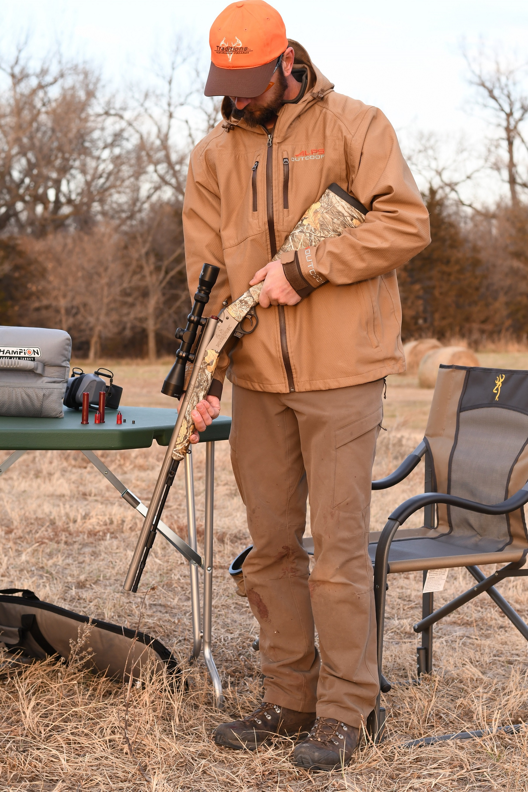
A muzzleloader is any firearm into which the projectile is loaded from the muzzle of the gun (from the open end of the gun’s barrel). Most (but not all) muzzleloaders used are considered antique firearms and are not defined as a “Firearm” according to the Gun Control Act of 1968. Antique firearms such as flintlock and caplock rifles use black powder flint and steel, or percussion caps for ignition and propellant functions.
Inline Muzzleloaders are more modern due to their inline ignition and propellant system. They work by pouring granular or pelletized black powder substitute into the muzzle and pushing down a sabot or bullet to seat it on top of the propellant. This step creates a guessing game to determine if the powder and bullet are seating properly and consistently. A 209 primer is then tediously installed in the breech of the rifle via a breech plug to fully charge the firearm. The firearm is then considered loaded.
With the new type of muzzleloader rifle that operates using the FireStick System, the inline system is dramatically easier. First, a bullet is loaded down the muzzle to seat on a bullet shelf within the rifle’s barrel. The bullet shelf provides a consistent seat point for the bullet and eliminates any need for a breech plug in the rifle. The charged FireStick with primer then gets inserted from the breech into the rifle. The firearm is then considered loaded.

What major advantages does the FireStick provide?
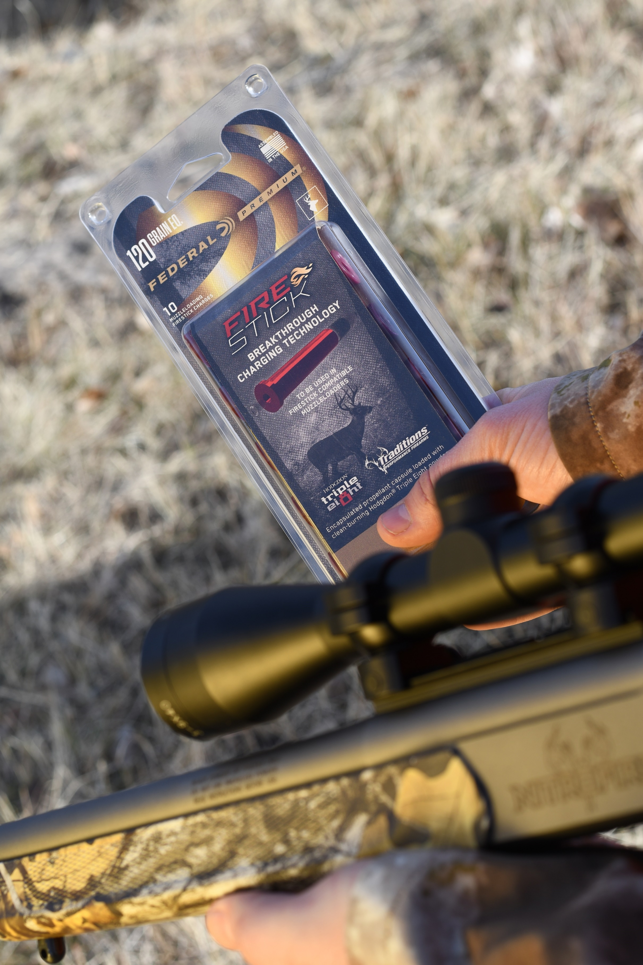
The primary benefit of the FireStick is best-in-class safety. The benefits of overall better shot consistency for better accuracy and ease of use follow close behind. That said, the list of rewards this product delivers include:

- It allows safe, easy removal of the unfired charge from the breech. The FireStick System is purposely designed to install and uninstall quickly, easily and safely by simply slipping it in or out of the breech. This allows for a safer hunting experience. FireSticks can quickly and easily be uninstalled whenever needed such as uninstalling to cross a fence, climb into a treestand, enter a blind, or ride in a vehicle.
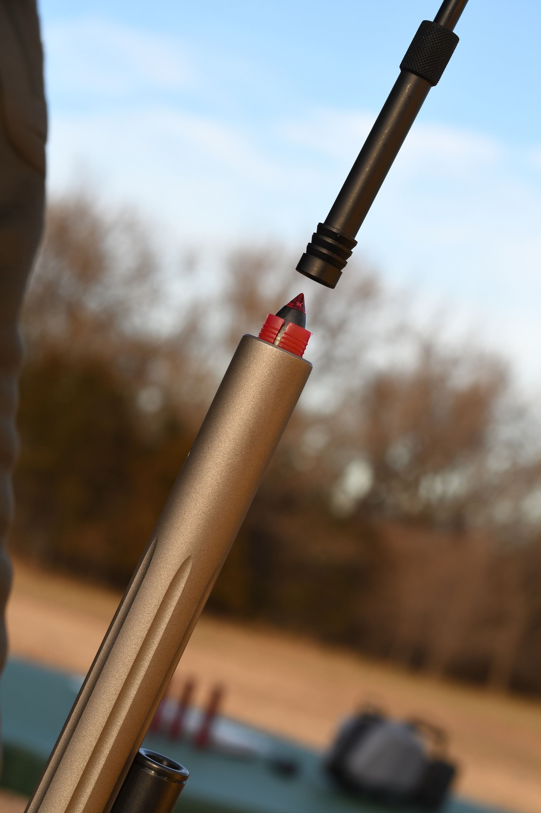
- The bullet is loaded first, separately, and is completely independent of the powder charge and primer. To unload the rifle, the bullet can simply be pushed out of the barrel. Use a ramrod and jag to push the bullet starting from the open breech, out through the muzzle. Due to the open breech, it is easy to see if the rifle is loaded with a bullet or not.
- The product delivers a safer shooting experience because using factory-controlled, precision-measured, pre-filled powder charges eliminates the risk of accidentally over-charging a rifle to dangerous levels.
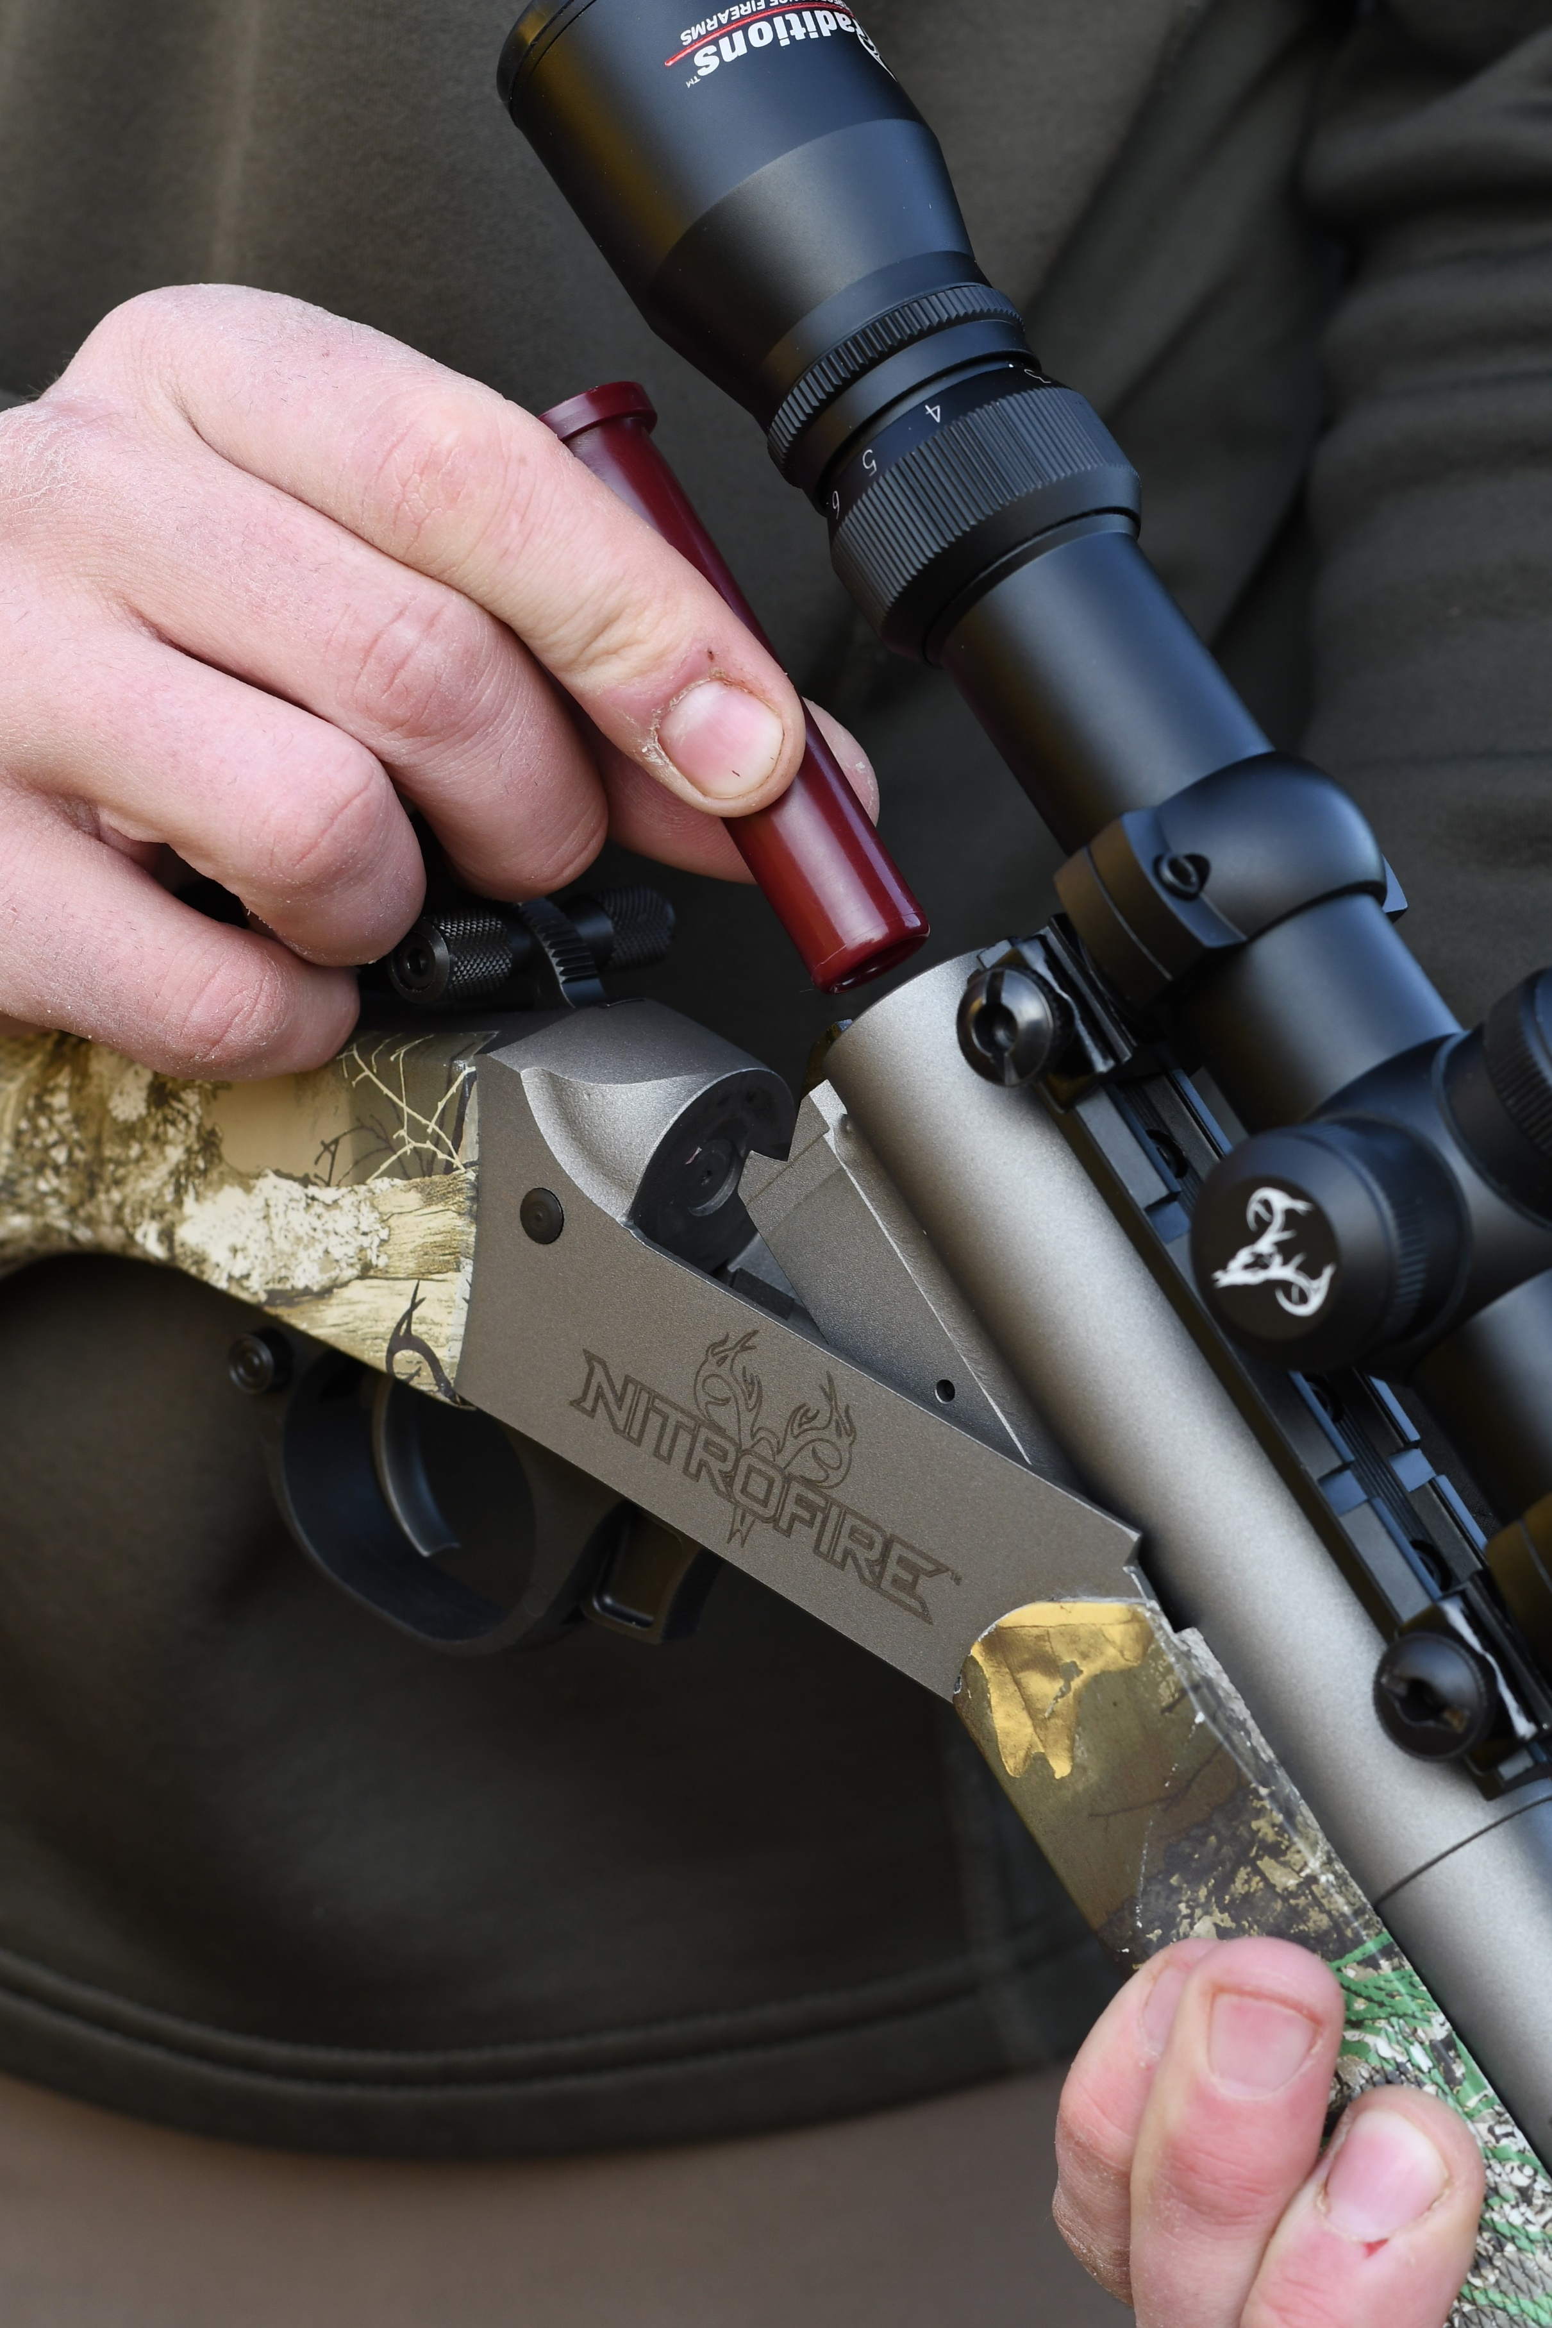
- Not having a breech plug to remove from the rifle adds another level of convenience. There is nothing in the breech to remove, clean, soak and lube. Breech plugs can become fouled quickly and even clogged and often need to be thoroughly picked and cleaned. This also means no hassles from stuck (frozen) breech plugs.
- There are no dirty or clogged breech plug issues. This results in better shot-to-shot reliability, and eliminates possible breech plug issues causing hang-fires. With the FireStick System, it’s like shooting a clean breech plug every time.
- When using a FireStick in a muzzleloader rifle designed for a FireStick, users can be assured they are using safe, correct products designed to be used in conjunction with each other.
- The charge is completely encapsulated and impervious to moisture, allowing for consistent, accurate shots, every time. It can be also stored for later use.
- It is loaded with clean-burning Hodgdon Triple 8 powder to the same tight tolerances as Federal Premium factory ammunition, ensuring shot-to-shot consistency and accuracy muzzleloaders have never experienced.
- Hodgdon Triple 8 powder is clean burning and the firearm is less dirty after every shot compared to older, less advanced powders.
- The quick-operation of the system allows for speed and convenience with less wasted time at the shooting range. There is no hassle of pouring granular powder or putting in pellets to charge the rifle.
What are the available powder-load options for FireStick?
At product launch, two pre-loaded FireStick charge levels are available: 100-grains or 120-grains Hodgdon Triple 8. Users can expect projectile velocities equal to or better than what they are getting with equivalent loads from other types of in-line muzzleloaders. Learn more about Hodgdon’s new Triple 8 muzzleloader powder by visiting www.hodgdon.com.
In the future, additional powder charge levels or charges using different powders could be offered. These options give shooters the ability to achieve other desired velocity options.
FireSticks are sold in 10-count packs and carry an MSRP of $26.95 per pack.

What bullets can be fired using the FireStick?
It’s the perfect match for Federal Premium Trophy Copper or Lead Tipped muzzleloader bullets.
These bullets’ exclusive B.O.R. Lock MZ System provides outstanding accuracy in a non-sabot design that's easy to load, scrubs fouling from the breech and ensures consistent bullet seating.
B.O.R. Lock MZ System features an expanding polymer base cup that engages rifling and seals the bore for extraordinary velocity and accuracy. Its high ballistic coefficient flattens trajectories and minimizes wind drift. The required loading force averages about half that of most sabots. B.O.R. Lock MZ’s non-sabot design is approved for hunting in most areas.
That said, Federal’s FireStick is compatible with any brand of muzzleloader bullets. The decision is up to the shooter on what bullet works best in their rifle.

What primers are recommended to be used with the FireStick?
Ignition is important in muzzleloading. That's why Federal Premium developed the 209 Muzzleloading Primers, Part No. PMZ209. The formulation provides superior resistance to moisture, as well as hot, reliable ignition of both granulated powder and pellets in any conditions. The design reduces the excessive breech fouling—also known as a “crud ring”—typical of standard shotshell primers. They are sold in 100-count packs.
However, any brand of muzzleloader-specific or 209 type primers could work with the FireStick system.
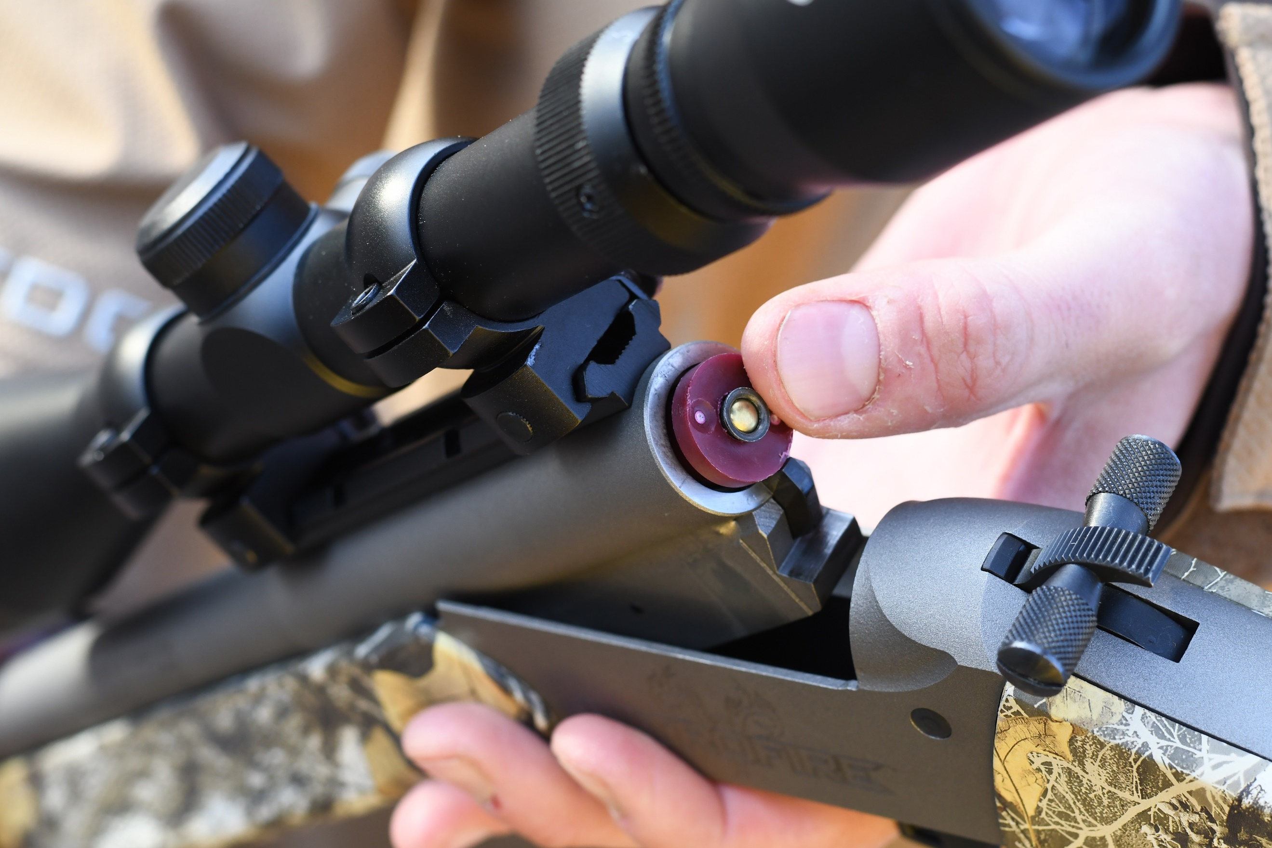
Why does the 209 Shotshell Primer need to be inserted by the consumer?
A separate primer allows the shooter to choose their preferred primer, and keeps with the traditional components of muzzleloading; bullet, powder, primer. Shipping the product without a primer also allows it to ship to dealers as powder, not ammunition.

When will FireStick products be available?
The official product announcement launch will happen during the 2019 SHOT Show (Booth No. 14551), January 21-24, 2020 at the Sands Expo Center in Las Vegas, Nevada. The first ship date for FireStick is targeted for May of 2020 from Federal’s Anoka, Minnesota factory. Yes, the product is proudly made in the U.S.A.
Please contact Traditions Firearms for availability of their NitroFire muzzleloader rifle which utilizes the new Federal Premium FireStick.

Are FireStick Rifles easier to clean?
Yes, partially because there are less parts to clean. The lack of a breech plug in the system makes access to the breech much easier to brush clean than standard 209 inline actions. There is no breech plug to remove, pick clean, soak and lube which removes entire steps in the overall cleaning process.
The new Hodgdon Triple 8 powder burns very efficiently and greatly reduces the amount of unburnt powder and residue in the barrels. Due to powder being in the capsule, there is no powder touching and igniting directly inside of the barrel. The bullet seats on the bullet shelf, not on top of powder. All this means the FireStick system generally reduces the traditional “powder ring” black powder shooters have come to recognize in the barrel after repeated firings. A powder ring left unclean can lead to barrel corrosion. With the FireStick, there is less or no powder ring to clean, so risk of barrel corrosion is also less.
The new Hodgdon Triple 8 is not designed for water-based clean-up. Using a cleaning solvent provides an effective and efficient job cleaning.

Is it possible for a FireStick rifle to accidentally fire a traditional centerfire or shotshell cartridge?
No. The polymer charge dimensions are chosen to prevent any dangerous combinations with any already existing centerfire or shotgun cartridges. FireStick rifles also feature a recessed firing pin designed to only strike a FireStick and not fire any already existing centerfire or shotgun cartridges accidentally inserted into the firearm.

Some states do not allow inline rifles. Where will the FireStick system be legal for hunting?
Research conducted by Federal Ammunition show that many states define a muzzleloader by the requirement of loading the projectile down the muzzle manually. By this definition, many states will allow the FireStick to be legal for hunting big game during their muzzleloader seasons. However, please check your states regulations and contact them with any questions. We are actively engaging with state game and fish departments to educate them on this new and innovative product.

Can a FireStick be reloaded and used again?
No. For safety reasons, FireSticks are designed for one-time use and cannot be reloaded.

What FireStick rifles will be available?
Upon product launch, Traditions has an exclusive arrangement utilizing the FireStick system. At the time of print, one NitroFire .50 caliber rifle is available from Traditions. In addition, the company plans on launching several different rifles at various feature levels and price points to accommodate a wide range of customer preferences. Please visit www.traditionsfirearms.com for more information.
In the future, look for other major muzzleloading rifle manufacturers to release firearms using the FireStick system. Other calibers may be possible in the future as well.

Where can I buy a Traditions NitroFire rifle?
Anywhere Traditions Firearms muzzleloading rifles are sold. Please visit www.traditionsfirearms.com for more information.
Most muzzleloading rifles are not required to be sold by an FFL dealer and do not require a background check. However, the Department of Alcohol, Tobacco and Firearms (ATF) currently categorizes Traditions NitroFire muzzleloader rifle as one that does require an ATF Form 4473 to be completed and approved to purchase.

For more information and videos about Federal Ammunition’s new, ground-breaking FireStick and all other products from Federal ammunition, visit: federalpremium.com.

The contents of this article were produced by Federal and are supplied by the company. Permission is granted to copy, reformat and/or publish this article in whole or in part.

