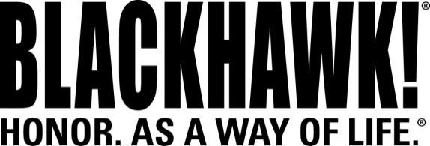

2015 NEW Products
Holsters

Leather Tuckable Pancake Holster
Concealed carry just got a whole lot easier. Constructed of premium leather and durable injection-molded plastic, the new BLACKHAWK!® Leather Tuckable Pancake holster combines the benefits of three holsters in one design. Buy one holster and choose inside-the-waistband, tuckable or belt-mounted wear. No matter how you choose to wear it, each design will contour to your body for exceptional comfort and concealment.

Features & Benefits
- Designed primarily for civilian and LE concealed carry
- Premium leather offers comfort, while rigid injection-molded plastic aids retention
- Three-slot design for strong-side, behind-the-hip, appendix and cross-draw carry
- Injection-molded removable/adjustable belt clips for custom cant and ride
- Belt clips for traditional inside-the-pants wear or use as tuckable holster
- Fits belts up to 1.75 inches wide
- Tension-adjustable retention
- Covered trigger guard for safety and security
- Built-in shirt shield for added comfort and to keep sweat away from gun

Part No. Description UPC MSRP
422001BK-L Leather Tuckable Holster, M&P 6 48018 18930 2 $86.95
422001BK-R Leather Tuckable Holster, M&P 6 48018 18929 6 $86.95
422009BK-L Leather Tuckable Holster, M&P Shield 6 48018 189469 $86.95
422009BK-R Leather Tuckable Holster, M&P Shield 6 48018 189456 $86.95
422004BK-L Leather Tuckable Holster, Ruger SP101/Taurus 85 6 48018 18936 4 $86.95
422004BK-R Leather Tuckable Holster, Ruger SP101/Taurus 85 6 480181 8935 7 $86.95
422006BK-L Leather Tuckable Holster, Kahr 9/40 6 48018 18940 1 $86.95
422006BK-R Leather Tuckable Holster, Kahr 9/40 6 48018 18939 5 $86.95
422034BK-L Leather Tuckable Holster, Xxxx 6 48018 $86.95
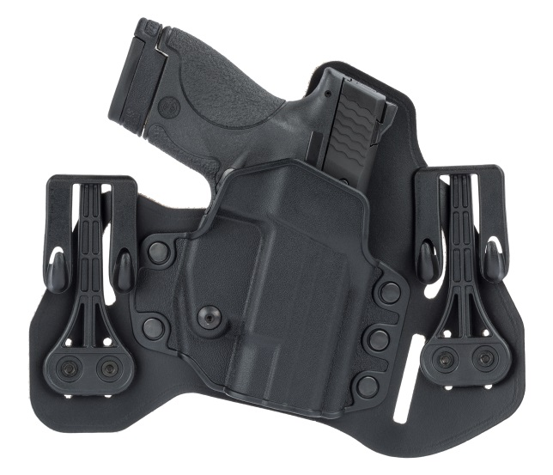
422034BK-R Leather Tuckable Holster, Xxxxx 6 48018 $86.95

